Pokhara University

Level: Bachelor | Semester – Fall | Year : 2010
Programme: BE |  | Full Marks : 100
 |  | Pass Mark : 45
Course: Electronic Circuits |  | Time : 3 hrs

Candidates are required to give their answers in their own words as far as practicable.
The figures in the margin indicate full marks.

Attempt all the questions.

1. | - Discuss the relative merits and demerits of RC coupled, transformer coupled and direct coupled multistage amplifier.  - Write the effect of emitter bypass capacitor on the low frequency responses. Discuss its gain effect with unbypass capacitor in common emitter configuration. | 8  7
2. | - “Cut-off points are also called as half power points”, Justify. What is Miller effect? Obtain the expression for its capacitance.  - Draw the circuit diagram of a class B power amplifier. Prove that its maximum efficiency is 78.5%. How would you eliminate the crossover distortion in class-B amplifier? | 7  8
3. | - To an amplifier of 60dB gain a feedback (negative) of β=6% is applied. What would be the change in the overall gain of the feedback amplifier if the gain of the amplifier decreases by 15%.  - State Barkhausen criteria for oscillation. Explain Colpitt oscillator with circuit diagram. Derive the expression for the frequency of the oscillator. | 7  8
4. | - Define difference amplifier. Also derive the expression for differential mode gain (A_{d}) of BJT difference amplifier.  - Design a practical differentiator that will differentiate signals with frequencies upto 200 Hz. The gain at 10 H_{z} should be 0.1.  - Design an operational amplifier circuit that will produce an output equal to (-4V₁+6V₂-0.3V₃). | 5  5  5
5. | - Draw the circuit of log-ratio amplifier and deduce the expression for the output voltage. How can you compensate its temperature effect?  - For a 5 bit R-2R current mode DAC, the value of the MSB is 2.5V. Compute the total power loss in R-2R ladder network, if the value of R = 20K_{2.} | 7  8
6. | - For the circuit below find:  - Output voltage.  - The current in the resistor, R.  - The collector to emitter voltage of the control element.  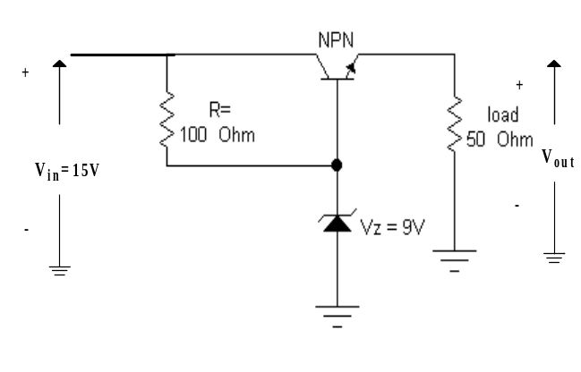  - Draw and explain Monostable multivibrator circuit using Op-amp. | 7  8
7. | Write short notes on (Any Two):  - Flash ADC  - Voltage controlled oscillator  - Tuned power amplifier | 2×5

